Network Security Lab

Submitted by
Palak Doshi
SAP ID: 500123198
R1242230121
B-03

B.Tech (Hons.) Computer Science and Engineering
Submitted to
Priyabrata Dash
(SOCS)



ATTACK FILES:
- TCP_file:
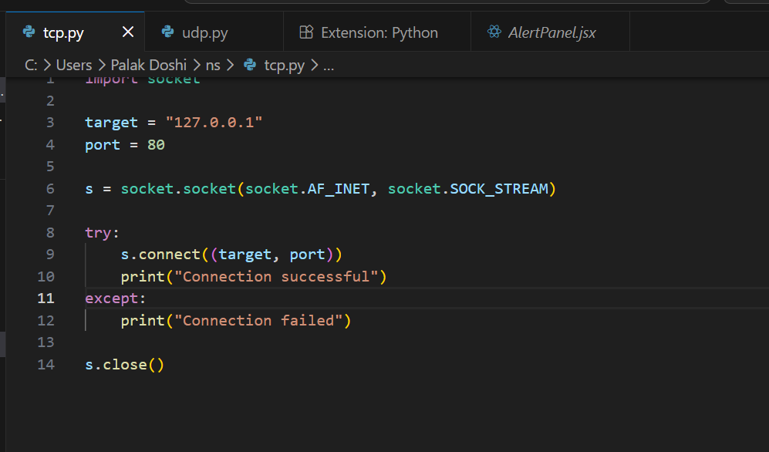
- UDP_file:
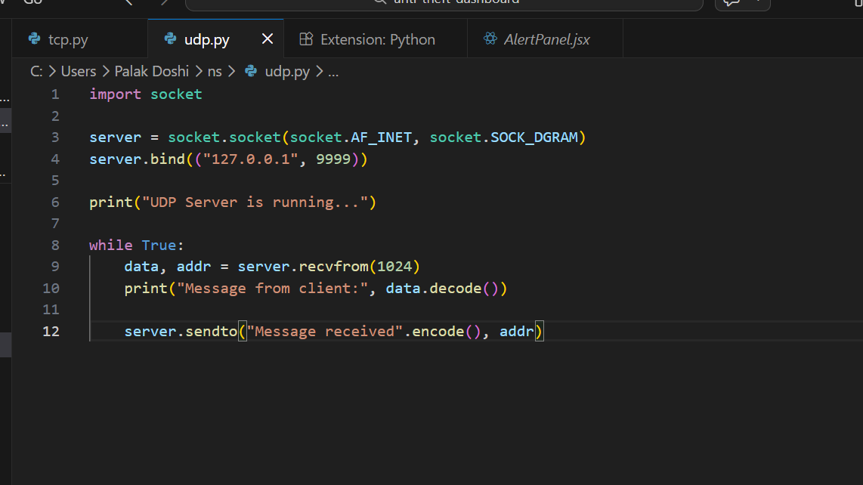

PACKET CAPTURING USING WIRESHARK:
- UDP packets:
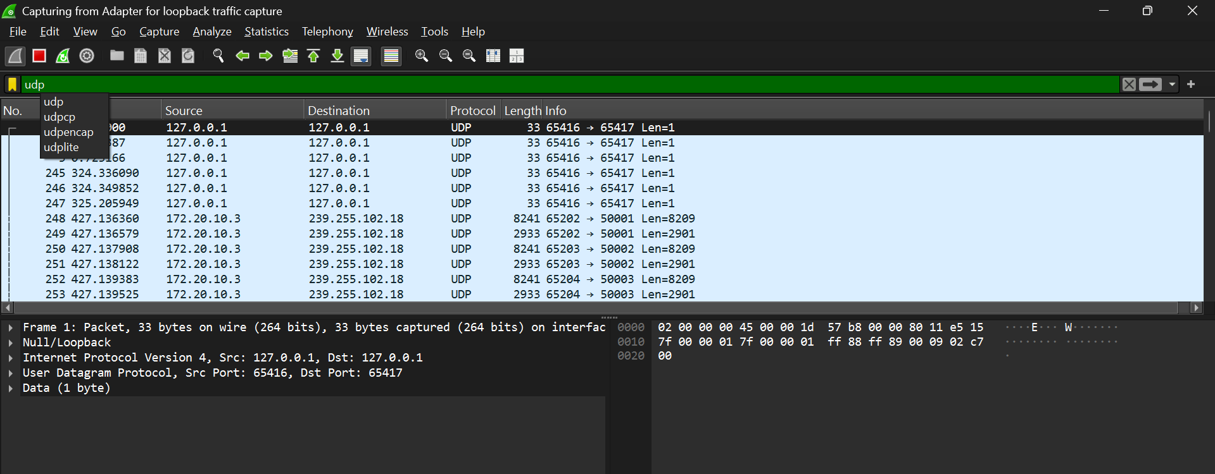
- TCP packets:
